horizontal line

**Takouba Security**

Veterans Affairs

Participatory System Dynamics Platform   
(to Increase Timely Access to VHA Evidence-based Outpatient Mental Health Care)

**Design Document -- Iteration B**

Tue 07-Nov 2017  
Version 6

horizontal line

# Document History & Status

|  |  |  |
| --- | --- | --- |
| Version | Date | Description/ Status |
| v 1 | 25-Sep 2017 | Start of Document / Development |
| v 2 | 24-Oct 2017 | Revised Page Flows, Notes for text |
| v 3 | 25-Oct 2017 | Some progress on screens; logic (written on plane and in MSP) |
| v 4 | 30-Oct 2017 | Version before updating “Decision Matrix by Team” and revised release schedule. |
| v 5 | 06-Nov 2017 | Revised schedule; reorder/rearrange/combine a few SOW elements; JMR UI updates from 05-Nov. |
| v 6 | 07-Nov 2018 | Release version for development. |



**Table of Contents (Quick Link)**

Document History & Status

Objective of This Document

Basics

Iteration Objectives

Key Dates

Graphic Standards and 508 Accessibility Standards

Vensim Model(s)

Roles

Page Flows and Wireframes

Page Groups & Flows

Wireframes

SOW Requirements

2.02 Admin’s Dashboard / Administration Features / 5.2.1. Basic Administrative Functionality for administration from the National Center for PTSD

2.02 Admin’s Dashboard / Administration Features / 5.6.2. Overview page with list of users and their current progress

2.03 Player’s Dashboard / 5.9.5 Timeline information, tracking progress against schedule

2.03 Player’s Dashboard / 5.9.10 Decisions Page

2.03 Player’s Dashboard / 5.9.6 Dashboard with access to key metrics

2.03 Player’s Dashboard / 5.9.11 Copy data to clipboard

2.03 Player’s Dashboard / 5.9.12 Ability to export data as a Comma Separated Values (CSV) File

2.03 Player’s Dashboard / 5.9.13 Players can create their own scenarios for comparison in session

[2.04 Retune the Model for Different Locations / 5.3.1 Framework for Multiple Cities, States, other Locations AND   
5.3.2 Ability to Upload Datasets by Location](#_uht4bu14r8jo)

2.05 User Management / 5.4.2 Upload List of Users from a Comma Separated Values (CSV) file

2.05 User Management / 5.9.4 Set team name

2.06 Game Assignment / 5.4.1 Creating Classes & Managing Different Classes (Provided by the Platform)

[2.09 Report / 5.9.7 In-game reports (assume 7 reports) AND   
2.07 Game Progress / 5.5.1 Compare scenario results AND  
2.07 Game Progress / 5.9.8 Scoring / Compare to Other Teams (Admin) AND  
2.09 Report / 5.7.1 Decision Matrix by Team](#_9yphvksjlkuk)

[2.11 Chat Feature / 5.6.3 View/Send Messages to Teams or Team Members AND   
2.11 Chat Feature / 5.9.9 Chat Feature to Interact With Other Teams](#_bl95xksv8b0p)

Iteration B Design-Related Questions

Recordings of Calls

Notes on Colors:

1. Most text is in black
2. We can use text color for different indications. For example, Purple is used as notes from Takouba about questions or items yet to be resolved.
3. Orange is to indicate a recent questions from WaferWire.
4. When questions are acknowledged/resolved we can turn it Dark Green 1, then eventually, back to black.

# Objective of This Document

1. This document describes the design for “Iteration B” for the Participatory System Dynamics Simulation.
2. The document is also used to track questions and clarifications during the development and potentially the testing phases of the project.
3. This document does NOT describe all the work to be performed during the Iteration B development period. For more information, please also refer to the separate document: “VA PSD -- Design Document -- Iteration A”.

# Basics

## Iteration Objectives

1. ~~Iteration A: Logon, basic UI, screen flows, initial input/output (few example elements).~~
2. ~~Iteration B: Select model/data, initial reports and output, initial user input, gameplay and session. NEED TO CHANGE~~
3. ~~Iteration C: Chat, monitor decisions, compare games, user/access management, videos and training-related, additional inputs and outputs.~~
4. ~~Iteration D: v1.0~~

Revised (01-Nov)

1. Iteration A: Logon, basic UI, screen flows, initial input/output (few example elements).
2. Iteration B: Initial reports and output, initial user input, gameplay and session, chat, compare scenarios/teams.
3. Iteration C: Exogenous events, user/access management, videos and training-related, additional inputs and outputs.
4. Iteration D: Full feature v1.0.

## Key Dates

1. ~~Design Finalized Date: Mon 30-Oct~~
2. ~~WW Development Due Date: Mon 20-Nov~~
3. ~~Submit to Client Date: Mon 27-Nov~~

Revised on 01-Nov

1. Design Finalized Date: Wed 08-Nov
2. WW Development Due Date: 04-Dec
3. Submit to Client Date: 11-Dec

## Graphic Standards and 508 Accessibility Standards

1. Colors
   1. Navy blue - #003F72; RGB 0, 63, 114
   2. Light blue - #0083BE; RGB 0, 131, 190
   3. Dark red - #772432; RGB 119, 36, 50
   4. Light red - #C4262E; RGB 198, 38, 46
   5. Green - #598527; RGB 89, 133, 39
2. Official standards
   1. The links below also have information about fonts, use of logos, and 508 compliance. If there are questions or issues with the standards or compliance, let’s discuss and see if we can use the Iterations to test.
   2. Links
      1. [Tier 1 Graphic Standards](https://www.va.gov/opa/publications/graphicstandards/va_graphicstandardsguide_508_0113.pdf) (Aug 2012)
      2. [Graphic Style Guide](https://www.vets.gov/playbook/downloads/VHA_Style_Guide_508.pdf) (508 compliant, Feb 2012)
      3. [VA Mobile Style Guid](https://mobile.va.gov/sites/default/files/files/VAMobileStyleGuide508compliant.pdf)e (508 compliant, Jul 2014)

## Vensim Model(s)

1. For all Iterations, the name of the Vensim file(s) will be:
   1. CC_PROD.vmf
   2. MM_PROD.vmf
   3. Psy_PROD.vmf
   4. Agg_PROD.vmf
2. For Iteration B, we will have CC, MM, and Psy vensim files (and associated information provided in this design document). As we had in Iteration A, the model is selected from the Select page.
3. The Vensim models and diagram to use for Iteration B: [or JMR to provide eps file.]
   1. CC_PROD_Iteration_B.vmf (this is based on XXX)
   2. MM_PROD_Iteration_B.vmf (this is based on XXX)
   3. Psy_PROD_Iteration_B.vmf (this is based on XXX)

Note: Disable the “Aggregate” model radio button on the Select page.

## Roles

1. We will have three roles for the simulation
   1. Administrator (or Admin, or Facilitator; these terms are used interchangeably throughout this document)
   2. Team Lead
   3. Player

|  |  |  |
| --- | --- | --- |
| Role | Examples | Description |
| Administrator (or Admin, or Facilitator; these terms are used interchangeably throughout this document) | 1. Lindsey Zimmerman 2. Jane Branscomb 3. Stacey Park 4. James Rollins 5. Howard Park | 1. These are instructors and other “core project” team members. 2. Administrators will also be able to access Admin-only screens/features. |
| Team Lead | NA at this time. | 1. At a given time, there is only on Team Lead for a team. 2. Only the Team Lead can select a Vensim Model and XL file for the team. |
| Player | NA at this time. | 1. This is the rest of the team members (aside from the Team Lead). |

# Page Flows and Wireframes

## Page Groups & Flows

**Figure 1**

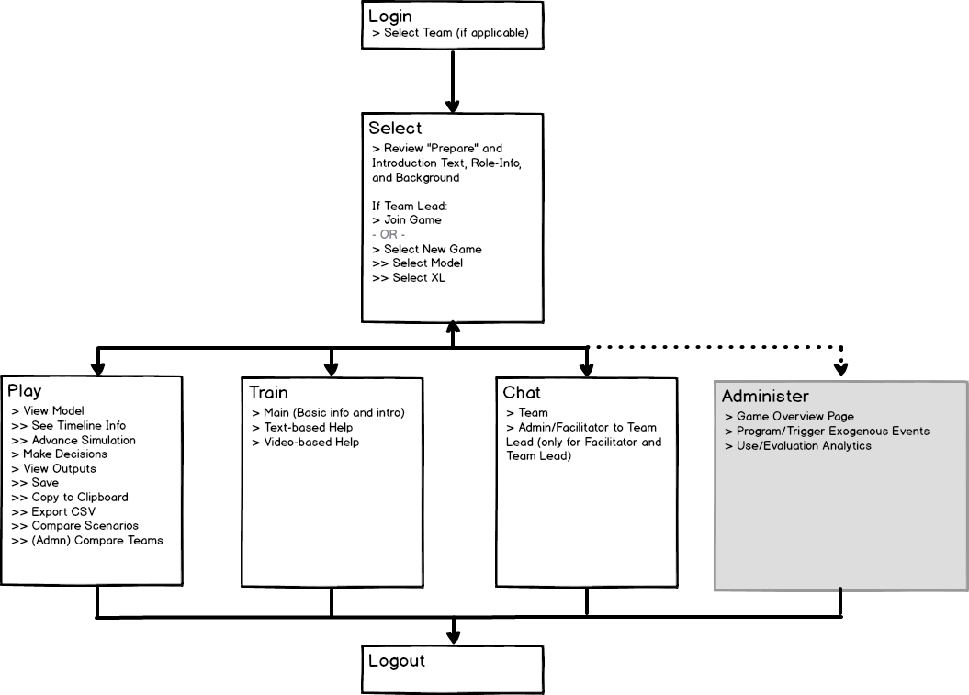

1. Login
2. Select
3. Play
4. Train
5. Chat
6. Administer (only for Administrator)

The following Table describes the Pages (or Sections or Tiles) in each Page Group.

|  |  |  |
| --- | --- | --- |
| Page Group | Page / Section / Tile | Description / Requirements |
| Select | 1. Main | 1. User can join an existing game or start a new game. 2. Existing game → page shows model selected and calendar status (and XL file selected?) 3. New game → select model and XL file 4. Note: we still have to investigate how Forio handles game status, teams, groups, etc. |
| Select | 2. Welcome | 1. Introductory text 2. Basic info, including navigation info (click “Play” to …) 3. “Prepare” info |
|  |  |  |
| Play | 3. Model |  |
| Play | 4. Gameplay | This is embedded into the “Model” tile. |
| Play | 5. Decisions | [ More clarification for Iteration B. ] |
| Play | 6. Outputs | 1. Graphs 2. Save 3. Export (csv) 4. Copy data to clipboard 5. Compare Scenarios |
|  |  |  |
| Train | 7. Main | 1. Basic info and intro |
| Train | 8. Text-based help | 1. TBD: with expandable topics? |
| Train | 9. Video-based help | 1. Video-based help (phone: landscape) |
|  |  |  |
| Chat | 10. Team Chat | [ Reworded for Iteration B, but functionality has not changed. ] |
| Chat | 11. Admin/Facilitator to Team Lead | [ Reworded and functionality is provided for Iteration B. ] |
| Chat | 12. Admin/Facilitator to Player | [ Reworded. Functionality is provided for Iteration B, but may not be needed. ] |
|  |  |  |
| Admin | 13. Game Overview | [ New for Iteration B. Functionality described below. ] |
|  | ~~14. Decisions Matrix by Team~~ | [ incorporated into Play > Outputs for Iteration B. ] |
|  | 14. Exogenous Events |  |
|  | 15. Use/Evaluation Analytics | [ New for Iteration B. Functionality described below. ] |

## Wireframes

1. The UI examples provided in the design documents for Iteration A and Iteration B were produced using two separate drawing applications. For the development work, we want one “look and feel” across the entire simulation. In general, we want tiles to look the same, so for example, a Tile that’s presented as Figure 02 (with the rounded edges, triangles to indicate expansion/collapse, icons, etc.) should have the look and feel of Figure 03 (blue bar, title across bar, etc.).

**Figure 02**

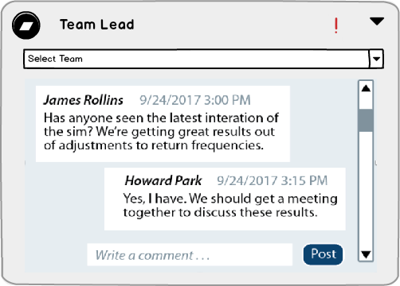  
  
 **Figure 03**

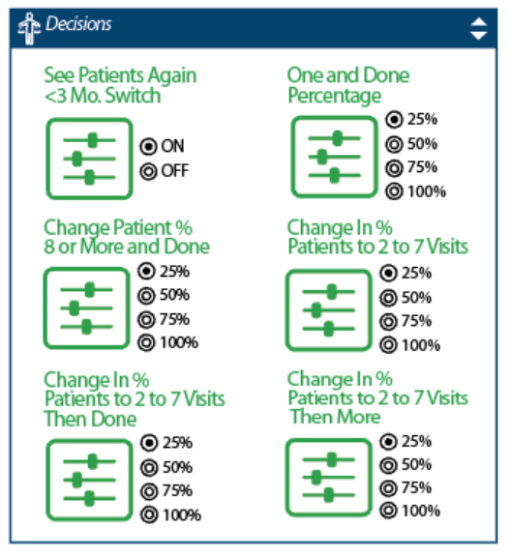

1. Play. The following is a revised version of the Wireframe for the Play page from what was provided for Iteration A.

**Figure 04**  
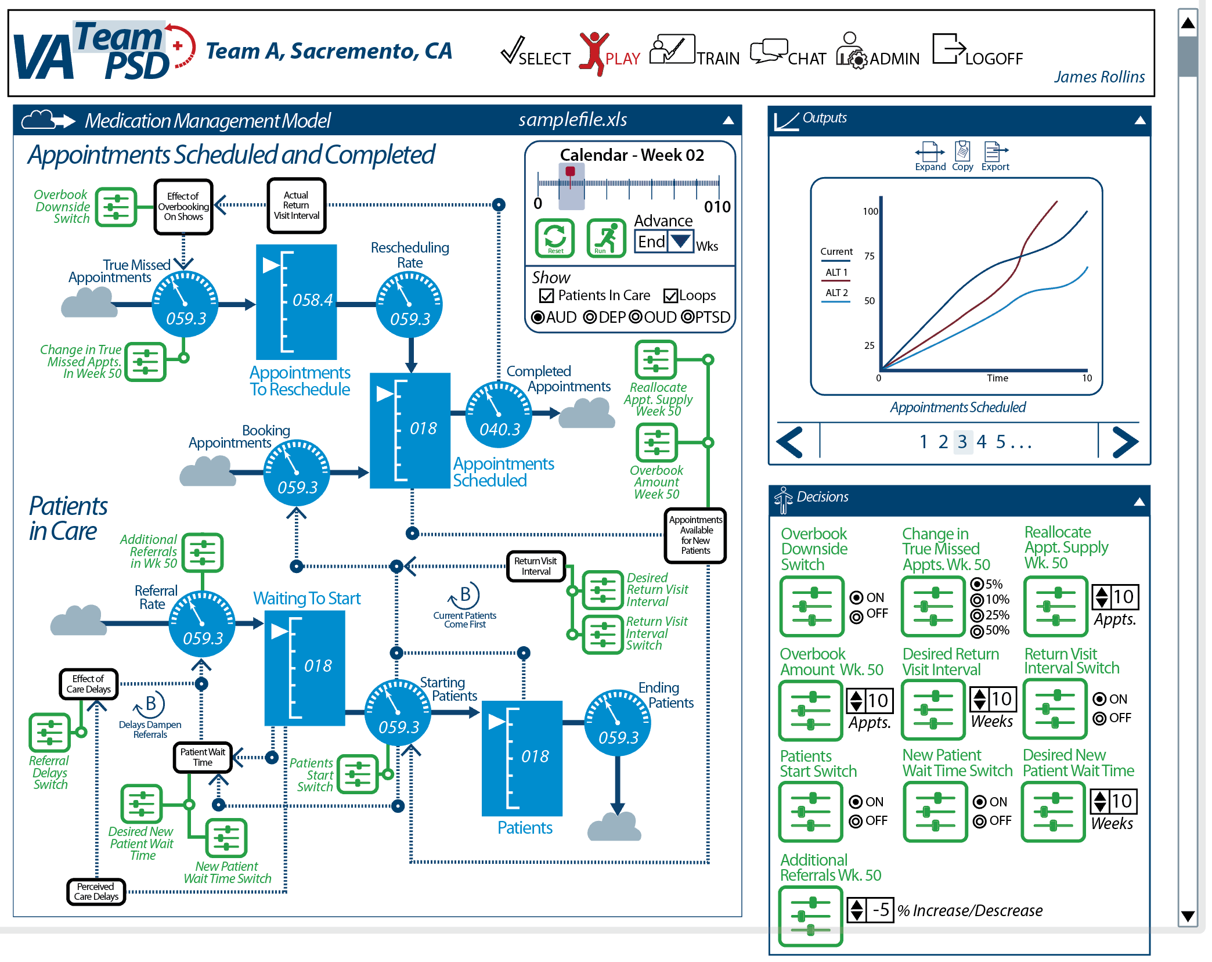  
  
Note: the above is for illustrating the wireframes (arrangement of the tiles) for the Play page; the specific elements (such as the Decision elements, the model for the “view model” visualization, etc.) may not be correct.

1. Outputs Tile
   1. Compared to Iteration A:
      1. The ability to scroll through (by clicking on the number or “<” and “>” remains the same.
      2. The variables for the graphs
         1. The variables in the Outputs Tile match the variables that are selected in the Expanded Output Tile.
         2. For each Vensim model, there are “default variables” that are shown for both the Outputs Tile (and the Expanded Outputs Tile). If the default variables are changed in the Expanded Outputs Tile, the Outputs Tile shows the new variables.
         3. The graphs also reflect whether the Expanded Outputs Tile is in Alternatives Comparison or Variables Comparison mode (more on this is described later in “Expanded Output Tile, in Model Run Alternatives Comparison Mode” and “Expanded Output Page, in the Inter-Model Run Variable Comparison Mode” below).
2. Expanded Output Tile - Administrator/Facilitator

**Figure 05**

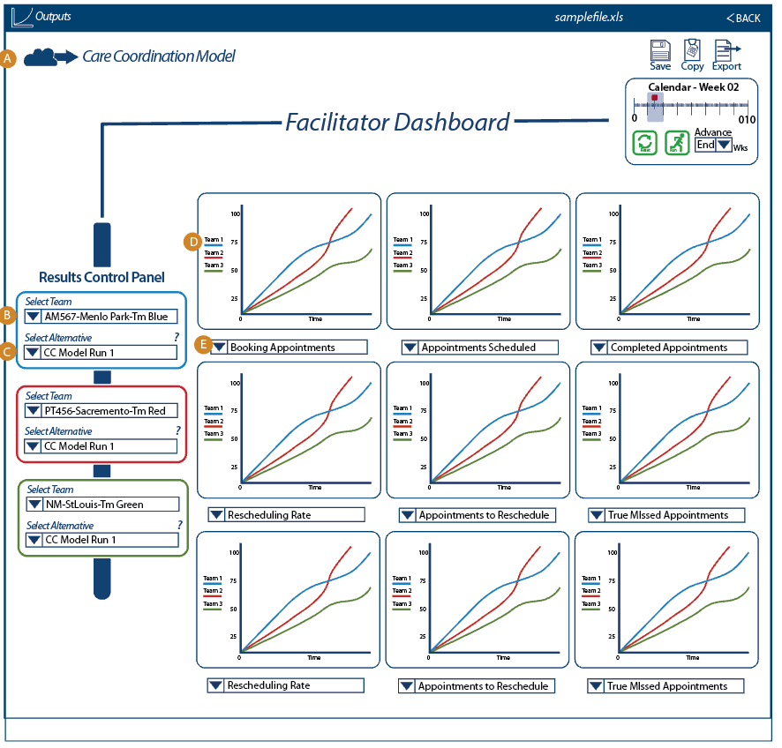

1. Model Title: The model is selected from the Play Page. This model title is listed here.
2. Team Selection Drop-down Menu: This drop-down will contain a listing of teams the Facilitator has access to. A naming convention is listed in section - - - -. The teams will be listed in alphanumeric order. The default team will be the first team in the alpha-numerical order. Once the team is selected, the teams’ saved model runs will be available to view in the “Select Alternative” drop-down.
3. Select Alternative: This drop-down will list the team’s saved model runs. They will be listed alphanumerically.
4. Graph: The graph legend will list team by color
5. Variable Selection Drop-down: see Variable Tables on page 27 for list of variables that will be saved and will be presented in this drop-down.
6. The following is the Expanded Output Tile, in Model Run Alternatives Comparison Mode for Team Lead and Player

**Figure 06**

* 1. Model identification: The Name of the model will be in the upper right. TheGreeking is a placeholder for a brief explanation of the purpose of the Expanded Outputs page, to be provided at a later date.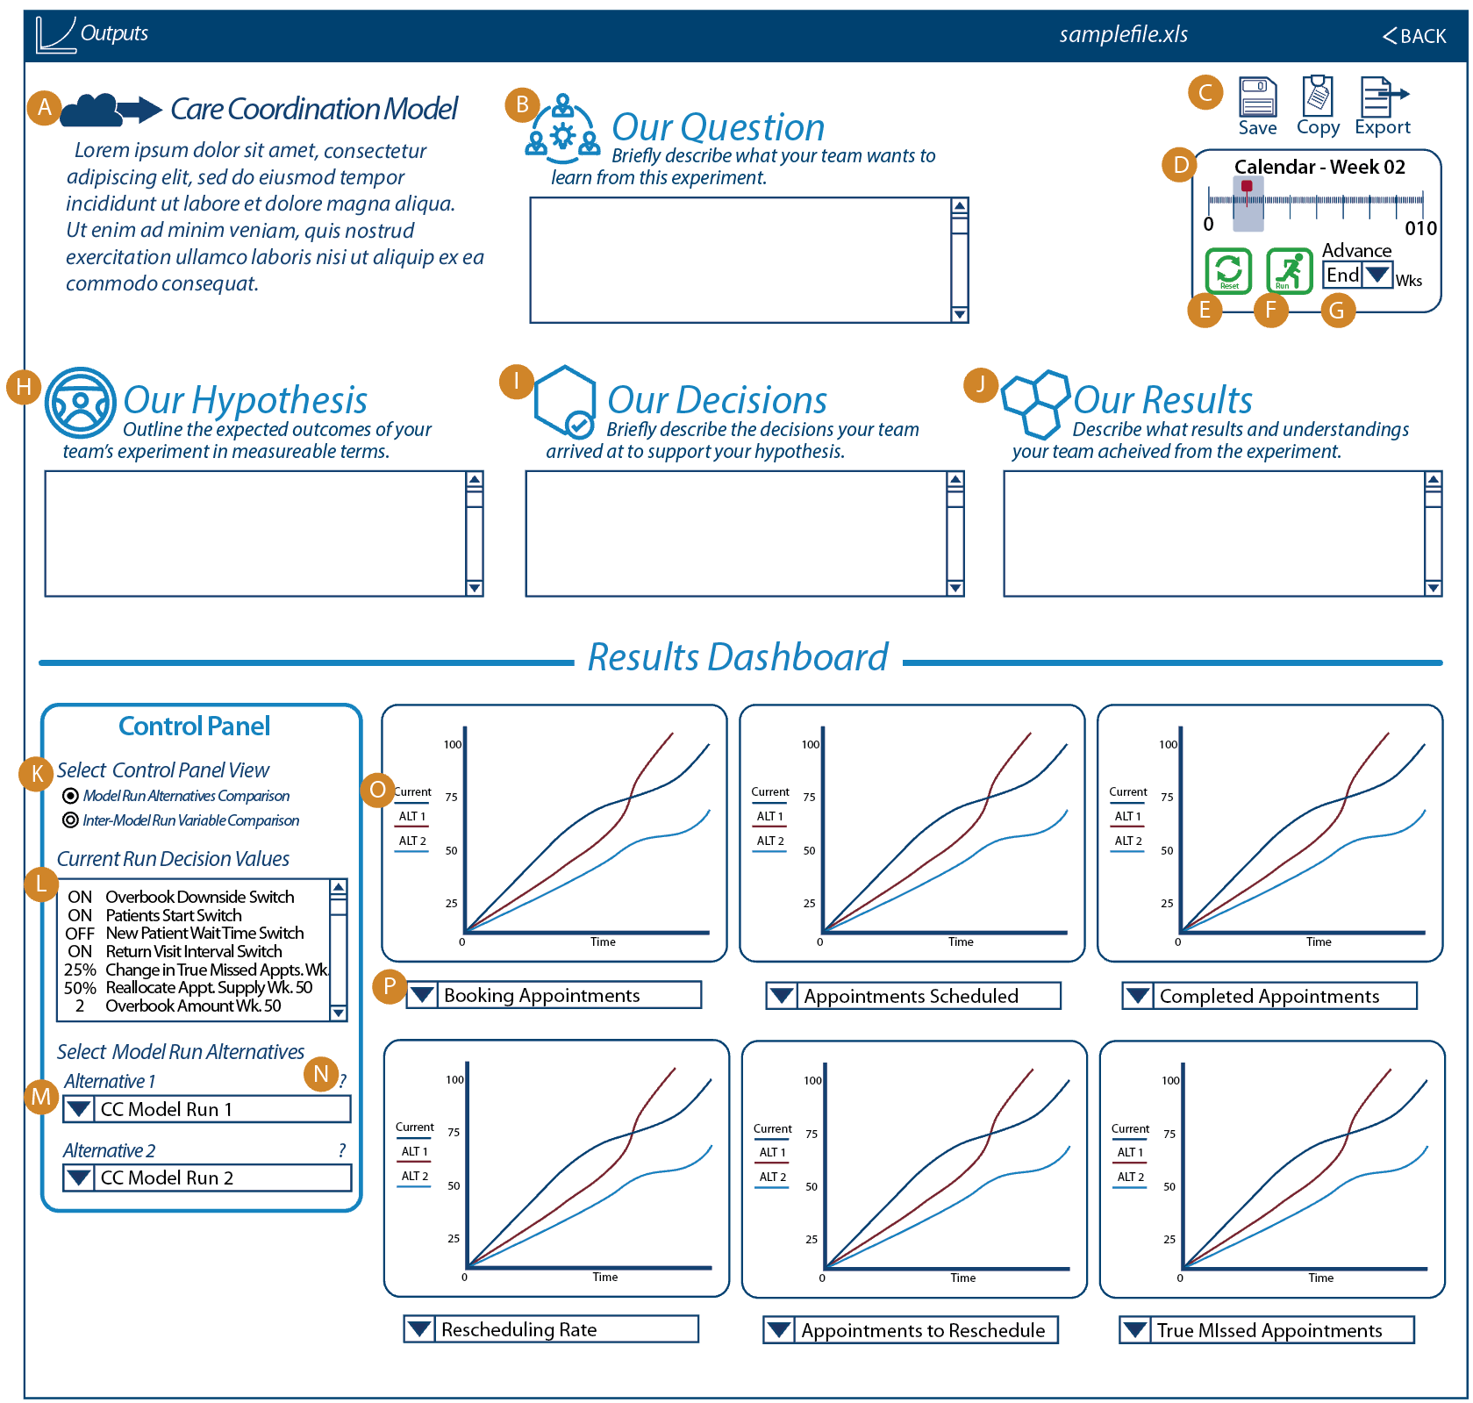
  2. Our Question: This a text field that will allow for user narrative input. The field will scroll as necessary using the scroll bar on the right side of the text field. The user input will be unlimited.
  3. Save, Copy, Export: These functionalities will be explained separately, see ____ for more information.
  4. Calendar: This function is placed in the upper right. The timeline will indicated the model’s current location on the timeline.
  5. Reset Button: This allows the user to reset the simulation to time 0 (zed).
  6. Run: This button will advance the simulation in the time increment indicated in the user input field (Advance) to the immediate right.
  7. Advance: This is a user input field that the user selects the time increment that the simulation will advance. The default value will be “End.” Below are the values to be indicated in the pull-down menu:
     1. End. (default value) (Will advance sim to the end)
     2. 1 (will advance sim 1 week)
     3. 3 (will advance sim 3 weeks)
     4. 5 (will advance sim 5 weeks)
  8. Our Hypothesis: This a text field that will allow for user narrative input. The field will scroll as necessary using the scroll bar on the right side of the text field. The user input will be unlimited.
  9. Our Decisions: This a text field that will allow for user narrative input. The field will scroll as necessary using the scroll bar on the right side of the text field. The user input will be unlimited.
  10. Our Results: This a text field that will allow for user narrative input. The field will scroll as necessary using the scroll bar on the right side of the text field. The user input will be unlimited.
  11. Select Control Panel View: There will be two radio buttons to switch between two Expanded Output screens. The two modes are “Model Run Alternatives Comparison” and “Inter-Model Run Variable comparison.” The Inter-Model Run Variable Comparison selection will only be available for models that are using Vensim Variable Arrays (such as the Medication Management Model).
      1. The default selection will be “Model Run Alternatives Comparison.”
      2. If the model does not use a Vensim Variable Array, then the selection for “Inter-Model Run Variable Comparison” will be grayed out and the user will not be able select this view.
  12. Current Run Decision Values: These values will be listed as text in a text box with a scroll bar on the right-hand side. The decision values listed here will reflect the values entered in the Decisions Tile of the Play Page.
  13. Alternative 1 and Alternative 2 Pull Down Menu: The user will select previously saved model runs from this drop down menu.
  14. ? : The Question Mark is active. When the user clicks on the Question Mark, the system will present a pop-up window that contains the header information and decision values for that saved model run. (see image - Pop-Up ALT 1 for an example).
  15. Graphs: The model variable data is expressed over time. A legend identifying each value will be placed on the left hand side of the graph.
      1. Each alternative is assigned the following color scheme:
         1. Black - Current Values
         2. Red - Alternative 1
         3. Light Blue - Alternative 2
      2. The 6 graphs shown will be presented from left to right, in the first row, then left to right in second row, as graphs 1 through 6 on the Outputs Tile of the Play page.
  16. Variables: Variables for the given model are made available in a drop-down menu for the user to select (See Model - Variable Tables for each model for information regarding the variables to be included in the drop-down menu).
      1. For models with Vensim Variable Arrays, in the Model Run Alternatives Comparison page, the drop-down menus will contain arrayed variables as an extension of the variable name. For example, the “Waiting to Start” variable, in the Medication Management Model would have the following choices in alphabetical order:
         1. Waiting to Start - AUD
         2. Waiting to Start - DEP
         3. Waiting to Start - OUD
         4. Waiting to Start - PTSD
      2. These Vensim Variable Arrays, as defined above, would NOT be available in the variable drop-down menu, if the Expanded Output page is in the Inter-Model Run Variable Comparison mode.
      3. Each Variable Drop Down will default to the variable listed as “default” in the Variable Tables.

**Figure 7**

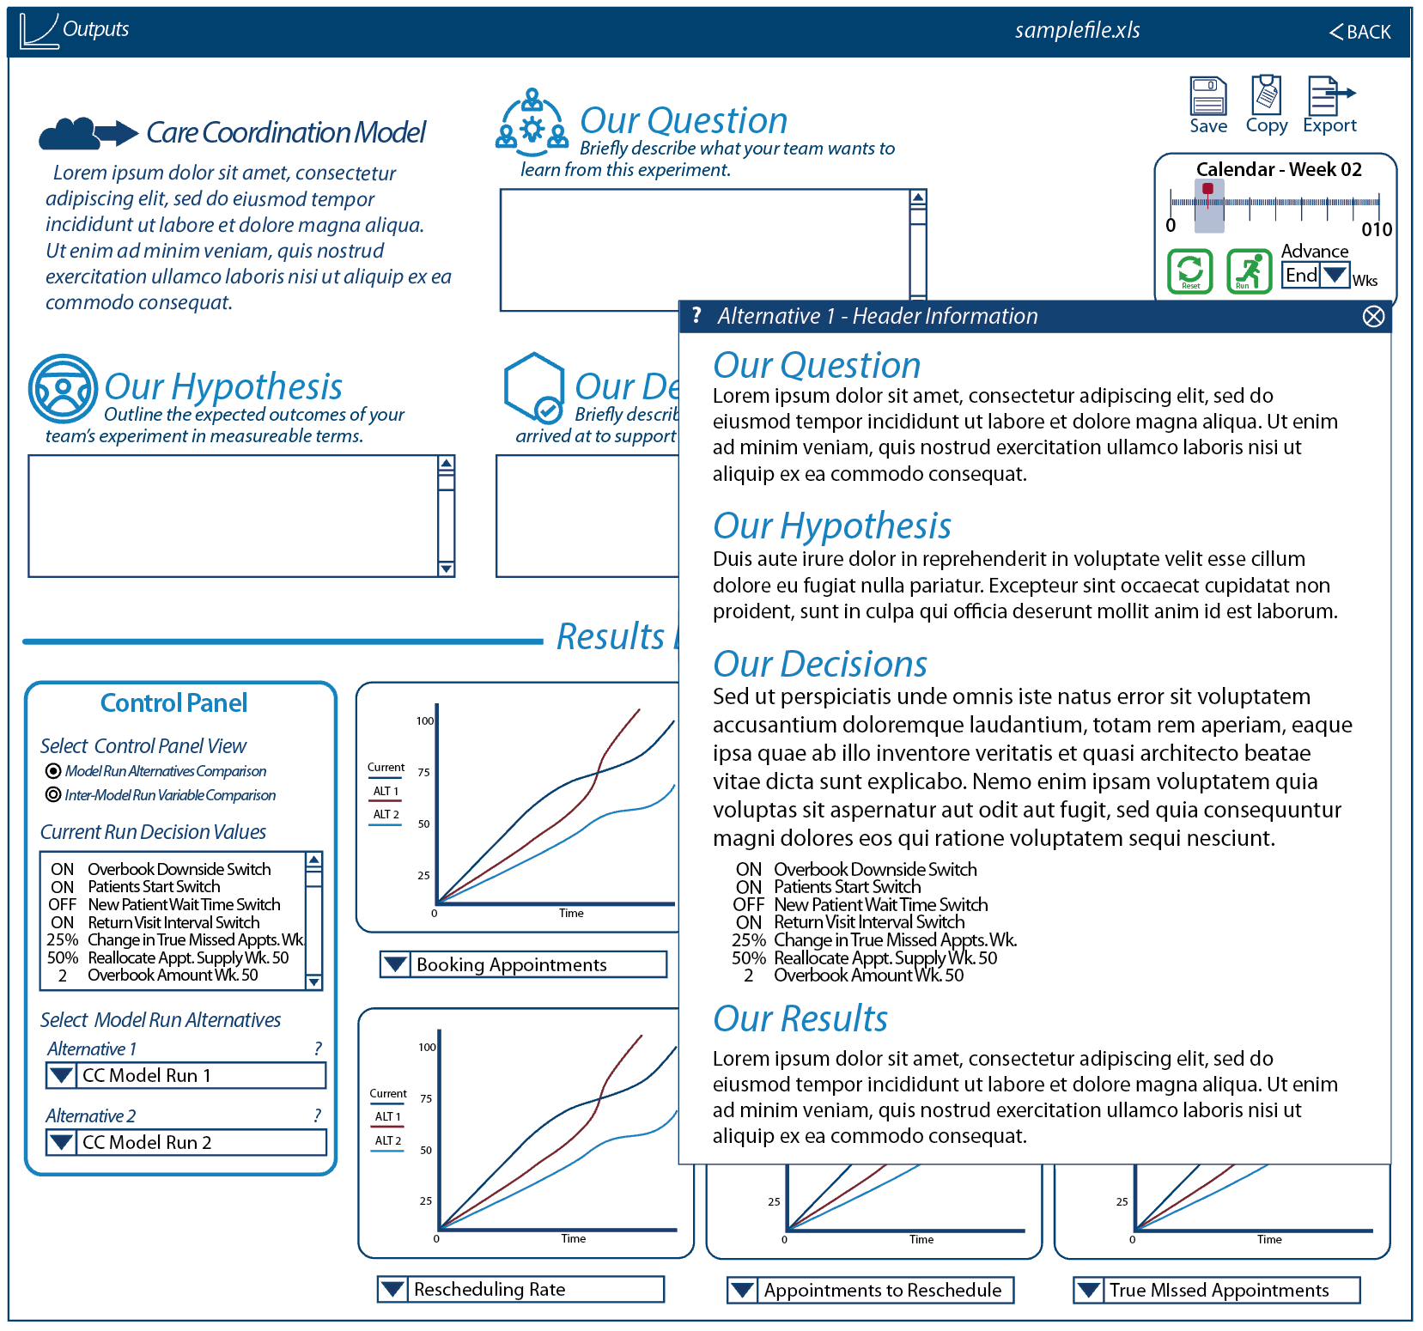

Example Pop-Up ALT 1 image. Please note that the Greeking text provided is a placeholder. The text is dynamic and loaded from the header information inputs from the saved model run.

6. The Following is the Expanded Output Page, in the Inter-Model Run Variable Comparison Mode for the MM model. This page will only display for models with Vensim Variable Arrays.

**Figure 8**

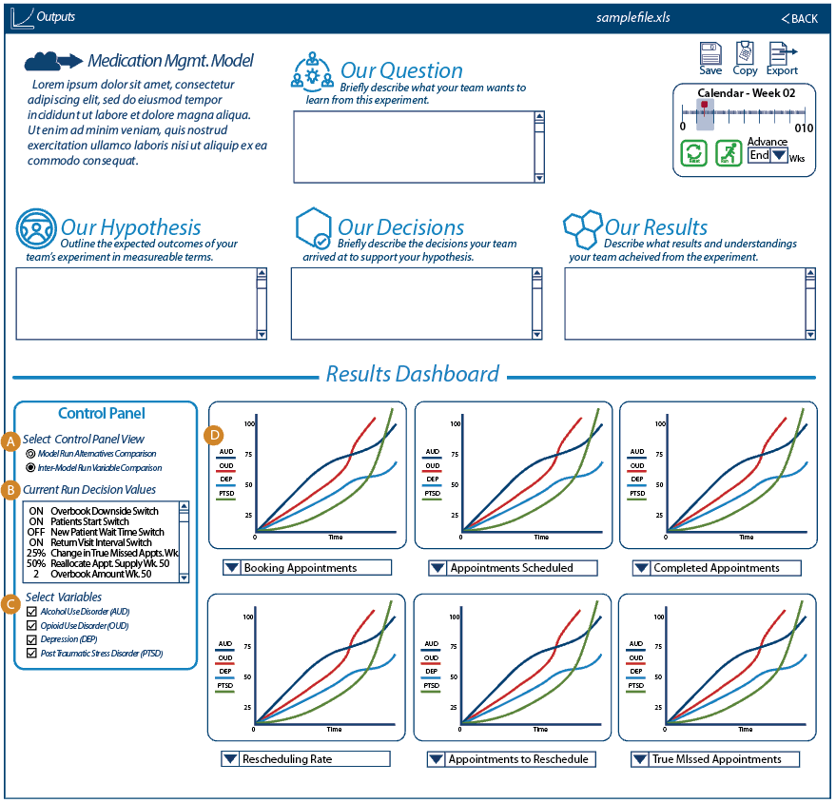

1. Select Control Panel View (Inter-Model Run selected): There will be two radio buttons to switch between two Expanded Output screens. The two modes are “Model Run Alternatives Comparison” and “Inter-Model Run Variable comparison.”
2. Current Run Decision Values This window contains the decision values from the user adjusted decision variables. This is a scrolling box for lists that exceed the length of the box. The box updates any time the decision values are changed.
3. Select Variables: These are check-boxes. The user selects the variables, from the array, that are desired on the charts to the right.
4. Variable Legend: The legend reflects the variables in the following orders:
   1. AUD - Navy Blue
   2. OUD - Bright Red
   3. DEP - Light Blue
   4. PTSD - Green

# SOW Requirements

This section describes the requirements as outlined in the SOW.

We list the requirements organized by WW’s SOW, then cross-listed to VA’s SOW (Statement of Work). More detail of the mapping of tasks can be found on “VA_PSD_Iterations_Features_HCP5.xlsx”.

The headings are in the format “WW Task / VA SOW”.

## 

## 2.02 Admin’s Dashboard / Administration Features / 5.2.1. Basic Administrative Functionality for administration from the National Center for PTSD

1. Many of the Administrative Functionality of provided by the Forio platform. For example: the ability to create teams and assign members, impersonate team players, etc.
2. For Iteration B, some of the other Administrative Functionality that are described in the following pages include:
   1. Admin-related chat
   2. Ability to observe decisions made by teams
   3. Ability to manage multiple teams across the same location
3. Not all the the Administrative Functionality is is described in the design for Iteration B; there are expanded or more detailed requirements for Iteration C.

## 2.02 Admin’s Dashboard / Administration Features / 5.6.2. Overview page with list of users and their current progress

**Figure 09**  
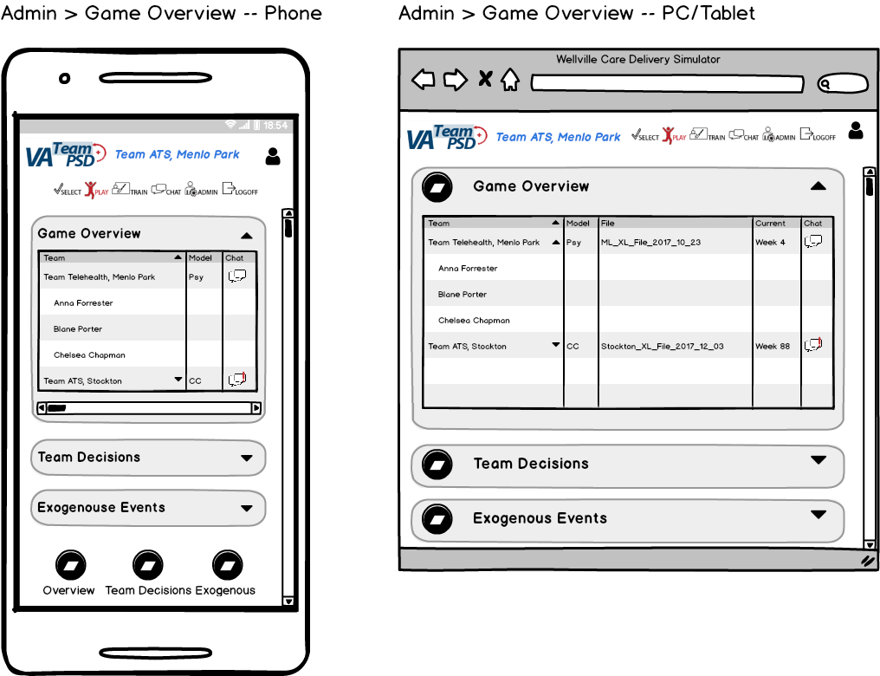

1. Game Overview is ONLy available for the Admin User. (The UI incorrectly shows “Play” as highlighted; it should be “Admin”.
2. UI Elements
   1. There are two levels of information available on each row
      1. Each active TEam is listed, along with the Vensim model selected, XL file being used, current model time, and whether there is an unseen Chat message.
         1. If there is an unseen Chat message, the chat icon for that current game has a red exclamation point.
         2. Clicking on Chat icon takes the Admin to the Chat page.
         3. **Question to WW: Can we access data on last login?**

Yes, for logged in user we will get last login datetime.

* + 1. If an active game is “expanded” using the triangle icon next to Team, the team member names/IDs are shown.
  1. **Question to WW: can we have the Team name be alpha orderable and/or searchable?**
  2. On the Phone, the XL filename and current model time is available, but must be scrolled right to show.

## 2.03 Player’s Dashboard / 5.9.5 Timeline information, tracking progress against schedule

The simulation will show the current model time as indicated on the Pages described in Iteration A. There is no additional functionality requirement from what is described in Iteration A.

## 2.03 Player’s Dashboard / 5.9.10 Decisions Page

User Interfaces. Below are new and updated user interfaces for the CC, MM, Psy and Expanded Outputs Screens.

1. **Care Coordination (CC) User Interface.** *Graphics will be emailed as Care Coordination Model.eps (encapsulated postscript). Please ensure colors conform with color specifications on page 4.*

**Figure 10**

* 1. Rate Dial: The Rate Dial has been changed to a higher contrast white on light blue (#0083BE; RGB 0, 131, 190), using only half the circumference for gradations. The dial pointer will range from 270 to 90 degrees, and rotate clockwise. The space below the mid-line will be used for a numerical value.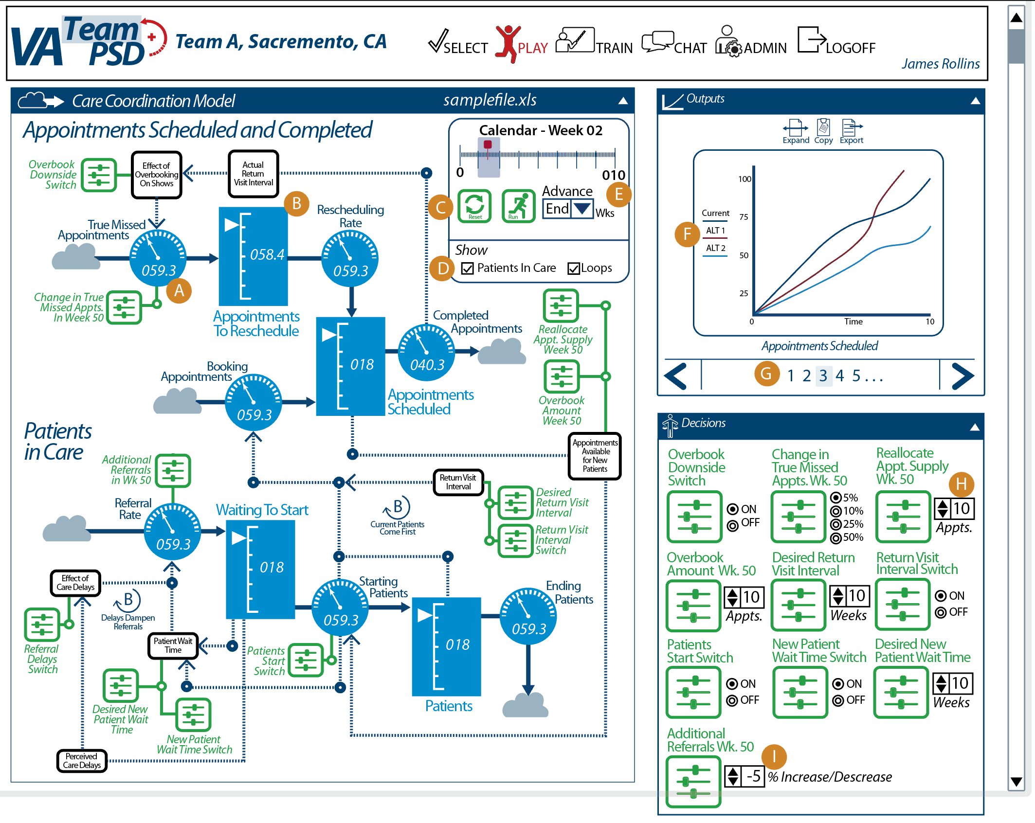
  2. Stocks. The Stocks gauge has been changed to the same color scheme as the rate dial.
  3. Simulation Reset Button. A reset button has been added to the Calendar so user may reset simulation from play screen.
  4. Show: The user turns on visual elements of the model by checking the “Patients in Care” and “Loops” boxes. See images below for an illustration of how this works.
  5. Advance: This is a user input field that the user selects the time increment that the simulation will advance. The default value will be “End.” Below are the values to be indicated in the pull-down menu:
     1. End. (default value) (Will advance sim to the end)
     2. 1 (will advance sim 1 week)
     3. 3 (will advance sim 3 weeks)
     4. 5 (will advance sim 5 weeks)
  6. Graphs: The graphs displayed on the Outputs tile will be consistent with the active view in the expanded outputs screen.
  7. Graphs Shown: The 6 graphs shown on the Expanded Outputs page will be presented on the Outputs tile, in order from left to right, in the first row, then left to right in second row, as graphs 1 through 6 on the Outputs Tile of the Play page. For example, the upper-left most graph on the Expanded Output screen will be graph 1 on the Output tile and the lower-right most graph will be graph 6.
  8. Decision Variable: The user can click the up-arrow to advance the number by +1 for each click, or -1 by clicking the down-arrow.
  9. Decision Variable: The user can click the up arrow to advance number by +1% or decrease by clicking down arrow. The values can go in the negative direction (i.e., -2%).

Below are screen views with respect to item d. Show, above. These views are also valid in the Medication Management (MM) Model.

View of screen showing Appointments Scheduled and Completed. Patients In Care and Loops are both turned OFF.

**Figure 11**

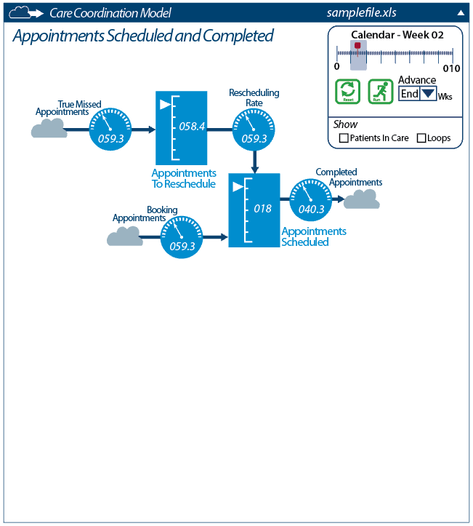

View of Screen Showing Patients in Care turned ON. Loops are turned OFF.

**Figure 12**

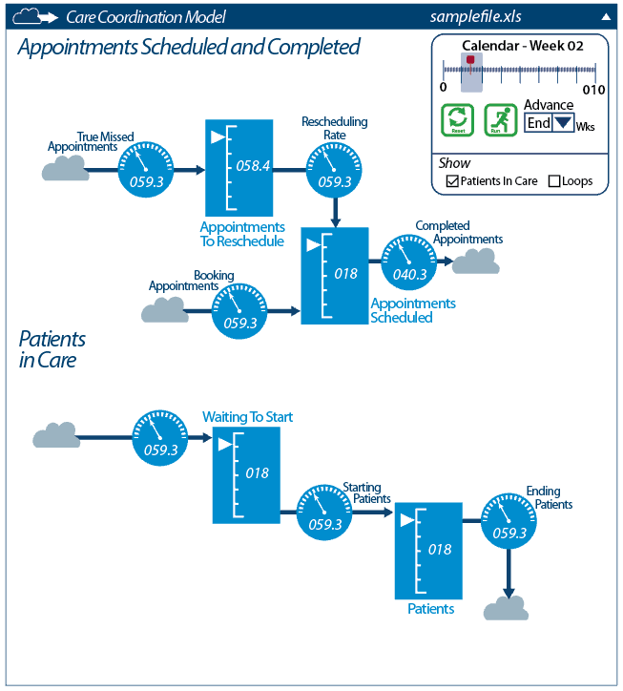

Below are all choices turned ON.

**Figure 13**

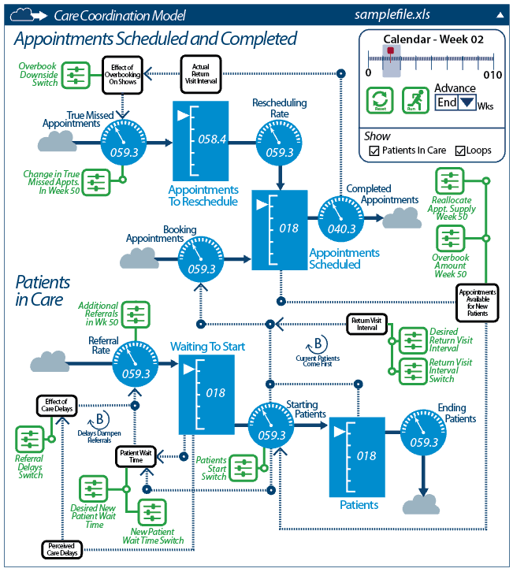

1. **Medication Management (MM) Model UI.** *Graphics will be emailed as Medication Management Model.eps (encapsulated postscript). Please ensure colors conform with color specifications on page 4.*

**Figure 14**  
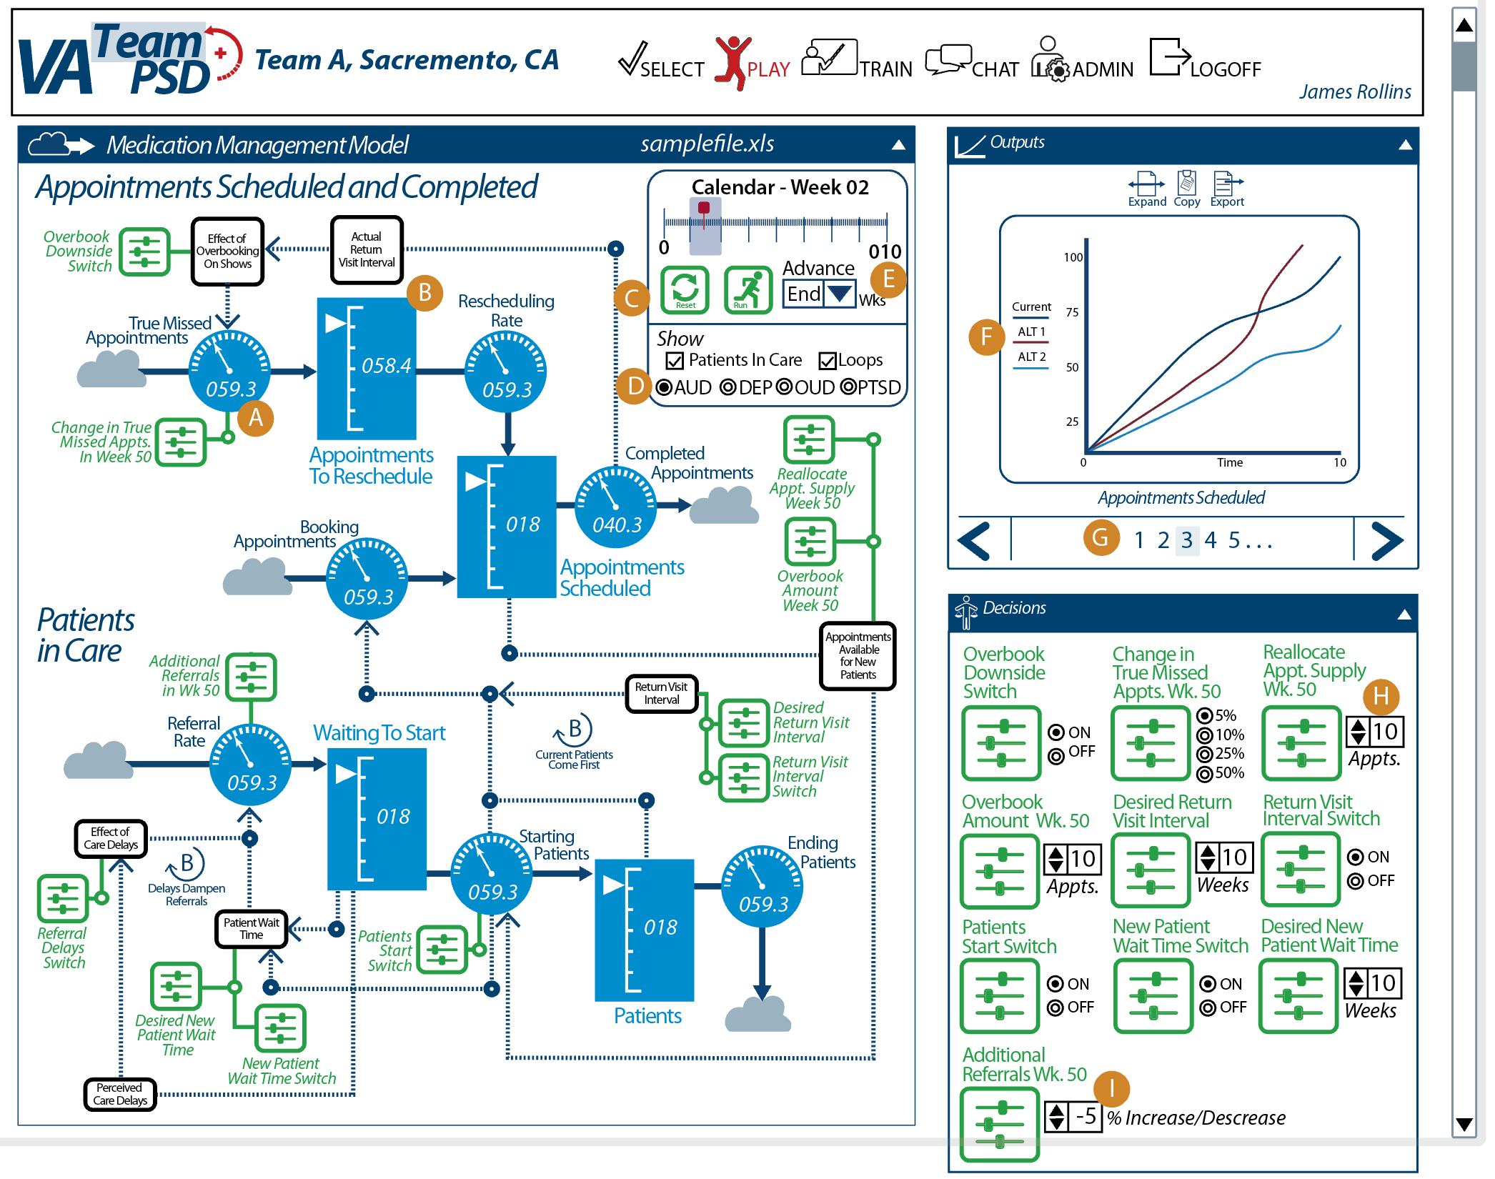

* 1. Rate Dial: The Rate Dial has been changed to a higher contrast white on light blue (#0083BE; RGB 0, 131, 190), using only half the circumference for gradations. The dial pointer will range from 270 to 90 degrees, and rotate clockwise. The space below the mid-line will be used for a numerical value.
  2. Stocks. The Stocks gauge has been changed to the same color scheme as the rate dial.
  3. Simulation Reset Button. A reset button has been added to the Calendar so user may reset simulation from play screen.
  4. Show: The user turns on visual elements of the model by checking the “Patients in Care” and “Loops” boxes or selecting desired Vensim Variable array using the radio buttons. See images in CC above for an illustration of how model views work. AUD/DEP/OUD/PTSD radio buttons will display appropriate variable values in the Patients in Care part of the model.
  5. Advance: This is a user input field that the user selects the time increment that the simulation will advance. The default value will be “End.” Below are the values to be indicated in the pull-down menu:
     1. End. (default value) (Will advance sim to the end)
     2. 1 (will advance sim 1 week)
     3. 3 (will advance sim 3 weeks)
     4. 5 (will advance sim 5 weeks)
  6. Graphs: The graphs displayed on the Outputs tile will be consistent with the active view in the expanded outputs screen.
  7. Graphs Shown: The 6 graphs shown on the Expanded Outputs page will be presented on the Outputs tile, in order from left to right, in the first row, then left to right in second row, as graphs 1 through 6 on the Outputs Tile of the Play page. For example, the upper-left most graph on the Expanded Output screen will be graph 1 on the Output tile and the lower-right most graph will be graph 6.
  8. Decision Variable: The user can click the up-arrow to advance the number by +1 for each click, or -1 by clicking the down-arrow.
  9. Decision Variable: The user can click the up arrow to advance number by +1% or decrease by clicking down arrow. The values can go in the negative direction (i.e., -2%).

1. Psychotherapy (Psy) Model UI. *Graphics will be emailed as Psy Model.eps (encapsulated postscript). Please ensure colors conform with color specifications on page 4.*

**Figure 15**

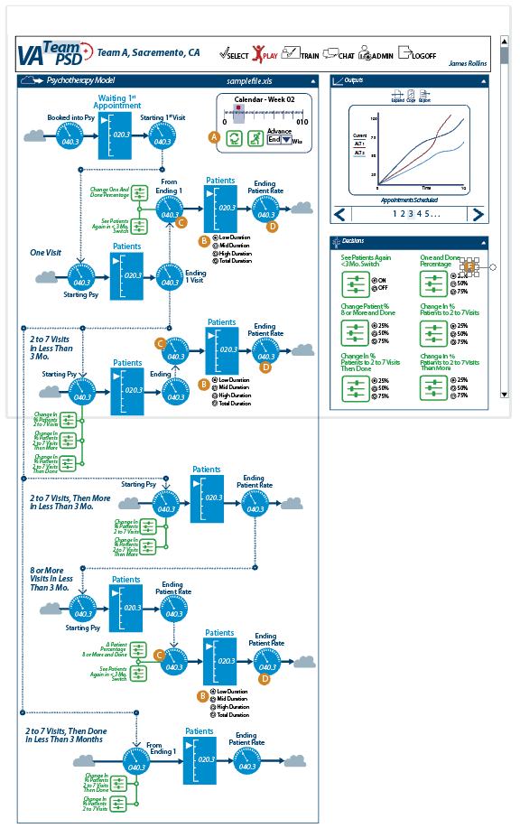

* 1. Calendar: The Calendar function only contains a “Reset” and “Run” button and an Advance drop-down menu to set the advance time - increment. The default value for the Advance function will be “End.” Below are the values to be indicated in the drop-down menu:
     1. End. (default value) (Will advance sim to the end)
     2. 1 (will advance sim 1 week)
     3. 3 (will advance sim 3 weeks)
     4. 5 (will advance sim 5 weeks)
  2. Low, Mid, High and Total: The user may choose which stock and flow they desire to see, by clicking the associated radio button.
     1. The default radio button will be “Low.”
     2. The gauges and stocks as shown in B, C, and D will all reflect the values associated with the low, mid, high, total radio button selection.
     3. The “Total” function will be the sum of the Low, Mid, High values.

E. Decision Variables: The decision variables will use a radio button to determine the percentage of change for the variable. The three choices are 25%, 50% and 75%. The default value will be 25%.

1. **Variable Tables .** For Iteration B, we will have the following variables. (“Group” means which Radio Button group for visibility, if applicable; “NA” for “Units” means “not applicable” and does not have units.). All of these variables are available on the drop-down menus on the Expanded Outputs Tile. Variables in an array are listed with an extension in the Model Run Alternatives Comparison Page. These same variables are not listed with an extension on the Inter-Model Variable Comparison Page, as the variables themselves are selected with a checkbox. See descriptions on pages 12 - 15 for more details. If Default is indicated as “NA”, choose the midpoint value for Iteration B.
   1. CC

|  |  |  |  |  |  |  |  |
| --- | --- | --- | --- | --- | --- | --- | --- |
| **Vensim Variable** | **Label** | **Group** | **Unit** | **Min** | **Max** | **Default** | **Format/ Gradation** |
| Booking CC Apts Rate  (Default 1 - on Expanded Outputs screen) | Booking Appointments | Model Run Alternatives Comparison on Expanded Outputs Screen Variable Drop-down | Appointment/weeks | 0.00 | 200 | NA | 0.00, in 0.05 |
| Appointments in CC  (Default 2 - on Expanded Outputs screen) | Appointments Scheduled | Model Run Alternatives Comparison on Expanded Outputs Screen Variable Drop-down | Appointments | 1 | 200 | NA | 10 |
| Completing the CC Apts Rate  (Default 3 - on Expanded Outputs screen) | Completed Appointments | Model Run Alternatives Comparison on Expanded Outputs Screen Variable Drop-down | Appointments | 1 | 200 | NA | 10 |
| True Missed Apts Rate  (Default 4 - on Expanded Outputs screen) | True Missed Appointments | Model Run Alternatives Comparison on Expanded Outputs Screen Variable Drop-down | Appointments | 1 | 200 | NA | 10 |
| Appointments to Reschedule  (Default 5 - on Expanded Outputs screen) | Appointments to Reschedule | Model Run Alternatives Comparison on Expanded Outputs Screen Variable Drop-down | Appointments | 1 | 100 | NA | 5 |
| Rescheduling Appointments Rate  (Default 6 - on Expanded Outputs screen) | Rescheduling Rate | Model Run Alternatives Comparison on Expanded Outputs Screen Variable Drop-down | Appointments | 1 | 100 | NA | 5 |
| Referrals to CC Rate | Referral Rate | Model Run Alternatives Comparison on Expanded Outputs Screen Variable Drop-down | Appointments | 1 | 200 | NA | 10 |
| Patients Waiting to Start CC | Waiting to Start | Model Run Alternatives Comparison on Expanded Outputs Screen Variable Drop-down | Appointments | 1 | 200 | NA | 10 |
| Starting CC Rate | Starting Patients | Model Run Alternatives Comparison on Expanded Outputs Screen Variable Drop-down | Appointments | 1 | 200 | NA | 10 |
| Patients in CC | Patients | Model Run Alternatives Comparison on Expanded Outputs Screen Variable Drop-down | Appointments | 1 | 200 | NA | 10 |
| Ending CC Rate | Ending Patients | Model Run Alternatives Comparison on Expanded Outputs Screen Variable Drop-down | Appointments | 1 | 200 | NA | 10 |
| Overbook Downside Switch | Overbook Downside Switch | Decisions |  | 0 | 1 | 0 | 0 and 1 (Binary) |
| Change to True Missed Appointments in Week 50 | Change in the True Missed Appts. in Wk. 50 | Decisions |  | 5 | 50 | 5 | Radio Buttons  5, 10, 25, 50 |
| Reallocation of Appt Supply in Week 50 | Reallocate Appt. Supply Wk. 50 | Decisions |  | -100 | +100 | 0 | 1 or -1 (Percentage that can go negative) |
| Overbook Amount in Week 50 | Overbook Amount in Wk. 50 | Decisions |  | 0 | 50 | 0 | 1 |
| Desired RVI | Return Visit Interval | Decisions | Weeks | 0 | 10 | 0 | 1 |
| RVI Switch | Return Visit Interval Switch | Decisions |  | 0 | 1 | 0 | Binary |
| Patients Start Switch | Patients Start Switch | Decisions |  | 0 | 1 | 0 | Binary |
| New Patient Wait Time Switch | New Patient Wait Time Switch | Decisions |  | 0 | 1 | 0 | Binary |
| Desired New Patient Wait Time | Desired New Patient Wait Time | Decisions | Weeks | 0 | 25 | 0 | 1 |
| Additional Referrals in Week 50 | Additional Referrals Wk. 50 | Decisions |  | 0 | 25 | 0 | 1 |
| Referrals Delay Switch | Referrals Delay Switch | Decisions |  | 0 | 1 | 0 | Binary |

* 1. MM

|  |  |  |  |  |  |  |  |
| --- | --- | --- | --- | --- | --- | --- | --- |
| **Vensim Variable** | **Label** | **Group** | **Unit** | **Min** | **Max** | **Default** | **Format/ Gradation** |
| Booking MM Apts Rate  (Default 1 - on Expanded Outputs screen) | Booking Appointments | Model Run Alternatives Comparison on Expanded Outputs Screen Variable Drop-down | Appointment/weeks | 0.00 | 200 | NA | 0.00, in 0.05 |
| Appointments in MM  (Default 2 - on Expanded Outputs screen) | Appointments Scheduled | Model Run Alternatives Comparison on Expanded Outputs Screen Variable Drop-down | Appointments | 1 | 200 | NA | 10 |
| Completing the MM Apts Rate  (Default 3 - on Expanded Outputs screen) | Completed Appointments | Model Run Alternatives Comparison on Expanded Outputs Screen Variable Drop-down | Appointments | 1 | 200 | NA | 10 |
| True Missed Apts Rate  (Default 4 - on Expanded Outputs screen) | True Missed Appointments | Model Run Alternatives Comparison on Expanded Outputs Screen Variable Drop-down | Appointments | 1 | 200 | NA | 10 |
| Appointments to Reschedule  (Default 5 - on Expanded Outputs screen) | Appointments to Reschedule | Model Run Alternatives Comparison on Expanded Outputs Screen Variable Drop-down | Appointments | 1 | 100 | NA | 5 |
| Rescheduling Appointments Rate  (Default 6 - on Expanded Outputs screen) | Rescheduling Rate | Model Run Alternatives Comparison on Expanded Outputs Screen Variable Drop-down | Appointments | 1 | 100 | NA | 5 |
| Referrals to MM Rate  Variable Array:  AUD  DEP  OUD  PTSD | Referral Rate | Model Run Alternatives Comparison on Expanded Outputs Screen Variable Drop-down | Appointments | 1 | 200 | NA | 10 |
| Patients Waiting to Start MM  Variable Array:  AUD  DEP  OUD  PTSD | Waiting to Start | Model Run Alternatives Comparison on Expanded Outputs Screen Variable Drop-down | Appointments | 1 | 200 | NA | 10 |
| Starting MM Rate  Variable Array:  AUD  DEP  OUD  PTSD | Starting Patients | Model Run Alternatives Comparison on Expanded Outputs Screen Variable Drop-down | Appointments | 1 | 200 | NA | 10 |
| Patients in MM  Variable Array:  AUD  DEP  OUD  PTSD | Patients | Model Run Alternatives Comparison on Expanded Outputs Screen Variable Drop-down | Appointments | 1 | 200 | NA | 10 |
| Ending MM Rate  Variable Array:  AUD  DEP  OUD  PTSD | Ending Patients | Model Run Alternatives Comparison on Expanded Outputs Screen Variable Drop-down | Appointments | 1 | 200 | NA | 10 |
| Overbook Downside Switch | Overbook Downside Switch | Decisions |  | 0 | 1 | 0 | 0 and 1 (Binary) |
| Change to True Missed Appointments in Week 50 | Change in the True Missed Appts. in Wk. 50 | Decisions |  | 5 | 50 | 5 | Radio Buttons  5, 10, 25, 50 |
| Reallocation of Appt Supply in Week 50 | Reallocate Appt. Supply Wk. 50 | Decisions |  | -100 | +100 | 0 | 1 or -1 (Percentage that can go negative) |
| Overbook Amount in Week 50 | Overbook Amount in Wk. 50 | Decisions |  | 0 | 50 | 0 | 1 |
| Desired RVI | Return Visit Interval | Decisions | Weeks | 0 | 10 | 0 | 1 |
| RVI Switch | Return Visit Interval Switch | Decisions |  | 0 | 1 | 0 | Binary |
| Patients Start Switch | Patients Start Switch | Decisions |  | 0 | 1 | 0 | Binary |
| New Patient Wait Time Switch | New Patient Wait Time Switch | Decisions |  | 0 | 1 | 0 | Binary |
| Desired New Patient Wait Time | Desired New Patient Wait Time | Decisions | Weeks | 0 | 25 | 0 | 1 |
| Additional Referrals in Week 50 | Additional Referrals Wk. 50 | Decisions |  | 0 | 25 | 0 | 1 |
| Referrals Delay Switch | Referrals Delay Switch | Decisions |  | 0 | 1 | 0 | Binary |

* 1. Psy.

|  |  |  |  |  |  |  |  |
| --- | --- | --- | --- | --- | --- | --- | --- |
| **Vensim Variable** | **Label** | **Group** | **Unit** | **Min** | **Max** | **Default** | **Format/ Gradation** |
| Booked into Psychotherapy | Booked Into Psy |  | Pt/Week |  |  |  |  |
| Waiting for First Appointment | Waiting 1st Appointment |  | pt |  |  |  |  |
| Starting First Visit | Starting 1st Visit |  | pt/week |  |  |  |  |
| **One Visit** | | | | | | | |
| Starting Psychotherapy- 1 | Starting Psy |  | pt/week |  |  |  |  |
| <3mo Visit 1 | Patients |  | pt |  |  |  |  |
| Ending 1 | Ending |  | pt/week |  |  |  |  |
| From1-+3mo into Low D | From Ending 1 |  | pt/week |  |  |  | This variable activated with selection of “Low” radio button |
| From1-LowD | Patients |  | pt |  |  |  | This variable activated with selection of “Low” radio button |
| From1-+3mo Ending Low D | Ending Duration |  | pt/week |  |  |  | This variable activated with selection of “Low” radio button |
| From1-+3mo into Mid D | From Ending 1 |  | pt/week |  |  |  | This variable activated with selection of “Med” radio button |
| From1-MidD | Patients |  | pt |  |  |  | This variable activated with selection of “Med” radio button |
| From1-+3mo Ending Mid D | Ending Duration |  | pt/week |  |  |  | This variable activated with selection of “Med” radio button |
| From1-+3mo into High D | From Ending 1 |  | pt/week |  |  |  | This variable activated with selection of “High” radio button |
| From1-HighD | Patients |  | pt |  |  |  | This variable activated with selection of “High” radio button |
| From1-+3mo Ending High D | Ending Duration |  | pt/week |  |  |  | This variable activated with selection of “High” radio button |
| **2 to 7 Visits, Then Done In Less Than 3 Months** | | | | | | | |
| Starting Psychotherapy 2-7-n-Done | From Ending 1 |  | pt/week |  |  |  |  |
| <3mo Visit 2-7 -n-done | Patients |  | pt |  |  |  |  |
| Ending 2-7-n-Done | Ending Patient Rate |  |  |  |  |  |  |
| **2 to 7 Visits in Less Than 3 Mo.** | | | | | | | |
| Starting Psychotherapy 2-7-n-More<3mo | Starting Psy |  | pt/week |  |  |  |  |
| <3mo Visit 2-7-n-More<3mo | Patients |  | pt |  |  |  |  |
| Ending 2-7-n-More<3mo | Ending Patient Rate |  | pt/week |  |  |  |  |
| **2 to 7 Visits, Then More In Less Than 3 Mo.** | | | | | | | |
| Starting Psychotherapy- 2-7-n->3mo | Starting Psy |  | pt/weel |  |  |  |  |
| <3mo Visit 2-7-n->3mo | Patients |  | pt |  |  |  |  |
| Ending 2-7-n->3mo | Ending Patient Rate |  | pt/week |  |  |  |  |
| From2-7-+3mo into Low D | From Ending |  | pt/week |  |  |  | This variable activated with selection of “Low” radio button |
| From2-7-LowD | Patients |  | pt |  |  |  | This variable activated with selection of “Low” radio button |
| From2-7-+3mo Ending Low D | Ending Patient Rate |  | pt/week |  |  |  | This variable activated with selection of “Low” radio button |
| From2-7-+3mo into Mid D | From Ending 1 |  | pt/Week |  |  |  | This variable activated with selection of “Med” radio button |
| From2-7-MidD | Patients |  | pt |  |  |  | This variable activated with selection of “Med” radio button |
| From2-7-+3mo Ending Mid D | Ending Patient Rate |  | pt/week |  |  |  | This variable activated with selection of “Med” radio button |
| From2-7-+3mo into High D | From Ending 1 |  | pt/week |  |  |  | This variable activated with selection of “High” radio button |
| From2-7-HighD | Patients |  | pt |  |  |  | This variable activated with selection of “High” radio button |
| From2-7-+3mo Ending High D | Ending Patient Rate |  | pt/week |  |  |  | This variable activated with selection of “High” radio button |
| **8 or More Visits In Less Than 3 Mo.** | | | | | | | |
| Starting Psychotherapy- 8-12 | Starting Psy |  | pt/week |  |  |  |  |
| <3mo Visit 8+ | Patients |  | pt |  |  |  |  |
| Ending 8-12 | Ending Patient Rate |  | pt/week |  |  |  |  |
| From8++3mo into Low D | From Ending |  | pt/week |  |  |  | This variable activated with selection of “Low” radio button |
| From8+-LowD | Patients |  | pt |  |  |  | This variable activated with selection of “Low” radio button |
| From8+-+3mo Ending Low D | Ending Patient Rate |  | pt/week |  |  |  | This variable activated with selection of “Low” radio button |
| From8++3mo into Mid D | From Ending |  | pt/week |  |  |  | This variable activated with selection of “Med” radio button |
| From8+-MidD | Patients |  | pt |  |  |  | This variable activated with selection of “Med” radio button |
| From8++3mo Ending Mid D | Ending Patient Rate |  | pt/week |  |  |  | This variable activated with selection of “Med” radio button |
| From8++3mo into High D | From Ending |  | pt/week |  |  |  | This variable activated with selection of “High” radio button |
| From8+-HighD | Patients |  | pt |  |  |  | This variable activated with selection of “High” radio button |
| From8+-+3mo Ending High D | Ending Patient Rate |  | pt/week |  |  |  | This variable activated with selection of “High” radio button |
| **Decision Variables** | | | | | | | |
| Change in % Go on to 2-7 |  |  | Dmnl | 0 | 100 |  | Radio Button  25% (Default)  50%  75% |
| Change in %2-7-n-Done |  |  | Dmnl | 0 | 100 |  | Radio Button  25% (Default)  50%  75% |
| Change in %2-7-n-More<3mo |  |  | Dmnl | 0 | 100 |  | Radio Button  25% (Default)  50%  75% |
| Change in %Visit1-n-Done |  |  | Dmnl | 0 | 100 |  | Radio Button  25% (Default)  50%  75% |
| Change in %Visit8-12-n-Done |  |  | Dmnl |  |  |  | Radio Button  25% (Default)  50%  75% |
| See Patients \"From 1 Visit in <3mo\" again Switch |  |  | Dmnl | 0 | 1 |  | Binary Switch |
| See Patients \"From 8-12 Visit in <3mo\" again Switch |  |  | Dmnl | 0 | 1 |  | Binary Switch |

## 2.03 Player’s Dashboard / 5.9.6 Dashboard with access to key metrics

1. This requirement is fulfilled in the Expanded Outputs Page. Users can access the variables (from the drop-down) to access key metrics.
2. Upon entry into the Expanded Outputs Tile, there will be a set of metrics already selected (based on the Vensim model). For a list of these “default” metrics, please see description starting on the tables above.

## 2.03 Player’s Dashboard / 5.9.11 Copy data to clipboard

1. Clicking on the “Copy” icon (on the Outputs Tile or Expanded Outputs Tile) does the following:
   1. Logs the event for use in “Use/Evaluation Analytics”
      1. Date/time
      2. Team, Model, XL file, User
      3. Game Header Information (the text that is currently in “Our Question” Our Hypothesis”, “Our Results”, “Our Decisions”
      4. Current model time. For example, “Week 14”
   2. Places data in clipboard that matches the data and format described in XL file “Iteration_B_Components”, tab “Clipboard Data”.
2. The variables that are included are the variables that are currently selected as shown in the Expanded Outputs Tile.
   1. If the Expanded Outputs Tile is in Scenario Mode and Scenarios (other than the current game) is/are selected, each selected Scenario is also saved into the clipboard.

## 2.03 Player’s Dashboard / 5.9.12 Ability to export data as a Comma Separated Values (CSV) File

1. Clicking on the “Export” icon (on the Outputs Tile or Expanded Outputs Tile) does the following:
   1. Logs the event for use in “Use/Evaluation Analytics”
      1. Date/time
      2. Team, Model, XL file, User
      3. Game Header Information (the text that is currently in “Our Question” Our Hypothesis”, “Our Results”, “Our Decisions”
      4. Current model time. For example, “Week 14”
   2. Opens a dialog box asking the user where to place the CSV file. This includes a way for the User to name the file.
   3. Create a CSV file that matches the data and format described in XL file “Iteration_B_Components”, tab “Full Data Export”.
2. All Vensim variables and data for each timestep are saved.
   1. If the Expanded Outputs Tile is in Scenario Mode and Scenarios (other than the current game) is/are selected, each selected Scenario is also saved into the clipboard.

## 2.03 Player’s Dashboard / 5.9.13 Players can create their own scenarios for comparison in session

1. When the User clicks on Save (from the Expanded Outputs Tile), the following dialog box pops up:

**Figure 16**  
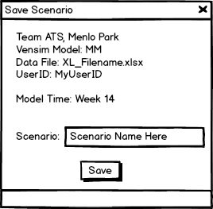

1. The top area is filled in with data from the current run.
2. The User can select a Scenario Name to save
3. User clicks “Save” to save the Scenario
   1. Error handling: If the Scenario Name already exists, an error message comes back with “Scenario Name already exists; please select a different Scenario Name.”
4. What is saved
   1. Metadata information, such as date/time, Team, Vensim Model, XL filename, ad UserID.
   2. All the user-provided text information such as “Our Question” Our Hypothesis”, “Our Results”, “Our Decisions”.
   3. All Vensim Variables and values for each time step.

## 2.04 Retune the Model for Different Locations / 5.3.1 Framework for Multiple Cities, States, other Locations AND 5.3.2 Ability to Upload Datasets by Location

There is no separate functionality to build for these requirements. These requirements are being fulfilled by:

1. How we are setting up teams to be a “team at a location”, for example “Team ATS, Menlo Park” is a team.
2. How we are enabling the use of external Excel files to bring in data for the Vensim model.
3. To manage the team names and Excel files, we recommend a easy-to-use naming convention.

## 2.05 User Management / 5.4.2 Upload List of Users from a Comma Separated Values (CSV) file

This is a feature already supported by Forio Epicenter. Takouba will provide a template with test data to test this feature.

## 2.05 User Management / 5.9.4 Set team name

This is a feature already supported by Forio Epicenter.

## 2.06 Game Assignment / 5.4.1 Creating Classes & Managing Different Classes (Provided by the Platform)

This is a feature already supported by Forio Epicenter.

## 2.09 Report / 5.9.7 In-game reports (assume 7 reports) AND 2.07 Game Progress / 5.5.1 Compare scenario results AND 2.07 Game Progress / 5.9.8 Scoring / Compare to Other Teams (Admin) AND 2.09 Report / 5.7.1 Decision Matrix by Team

These requirements are handled by the Expanded Outputs Tile. Please see descriptions above in the wireframes for the Outputs Tile and Expanded Outputs Tiles.

## 2.11 Chat Feature / 5.6.3 View/Send Messages to Teams or Team Members AND 2.11 Chat Feature / 5.9.9 Chat Feature to Interact With Other Teams

1. Overview
   1. Please see “Roles” above for description of the roles. Please note that we are using “Administrator”, “Admin”, and “Facilitator” interchangeably.
   2. For Iteration B, we want to implement two types of Chat:
      1. Team Chat
      2. Admin/Facilitator to Team Lead
      3. There is a potential 3rd chat functionality: “Admin/Facilitator to Player”. The following descriptions are provided as notes and do not reflect Iteration B requirements.
         1. This is similar to “Admin/Facilitator”, but the Facilitator can chat with someone other than a Team Lead
         2. The Facilitator would need to select a Team, then the individual Player.
         3. Question: what if a Player is in more than one team? Is there a way to still allow the Player to access the chat if logged into a different team? I.e., When a facilitator selects a Player, it’s really a way to “find” the Player. Let’s discuss with client.
         4. Also, we need to allow Player to “Select” the Facilitator? Or is the “pool” approach acceptable?
2. UI Components (general comments)
   1. Alignment rules -- Regardless of whether I am a Facilitator/Admin, Team Lead, or Player, my chats (i.e., my comments) are shown aligned to the RHS (right-hand side). For example, if I am a Facilitator, and there are two Facilitators chatting with a Team Lead, my chat is aligned RHS, and the Team Lead and other other Facilitator is aligned LHS (left-hand side).
3. Facilitator to Team Lead
   1. Facilitator View

**Figure 17**  
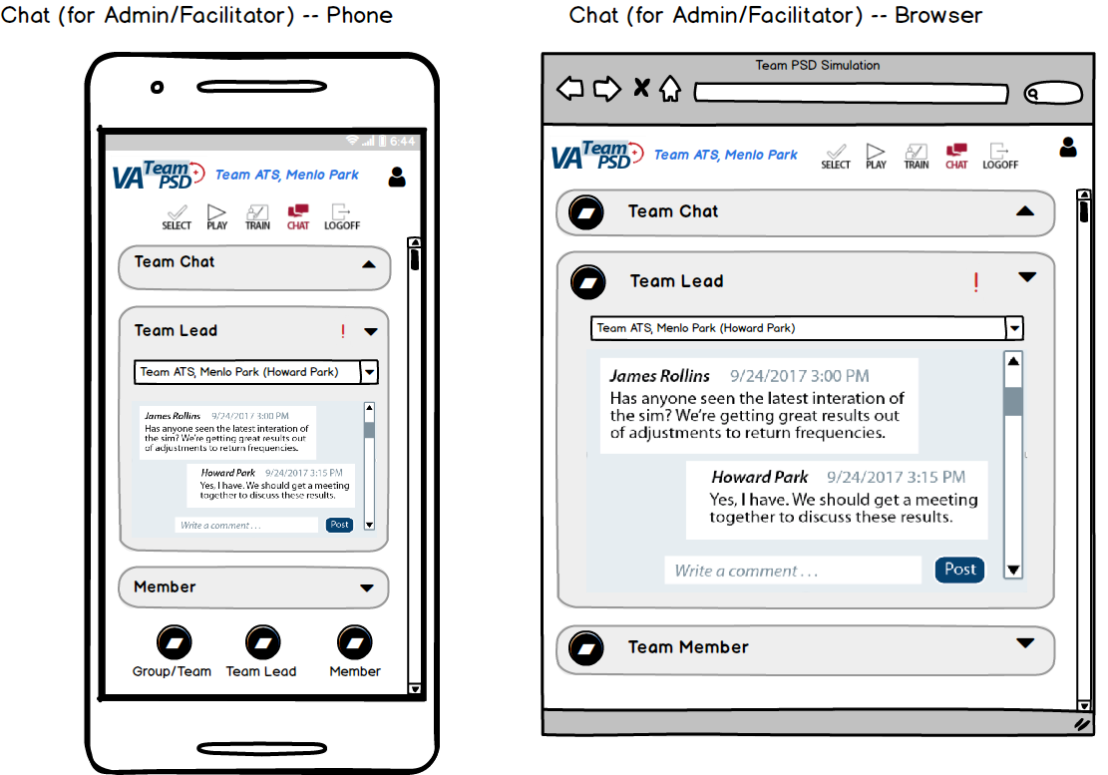

* + 1. The Team Lead Chat is a chat session between all Facilitators and the Team Lead for a specific team.
       1. All Facilitators can access the chat.
       2. If a User’s role changes from Player to Team Lead, the User can now access the previous chats from the Facilitators to the Team Lead.
    2. There are two ways for the Facilitator to enter and open the Team Lead tile:
       1. If the Facilitator enters the Team Lead Chat through the Game Overview tile (see Figure ###), the Team Lead Chat tile shows the Team selected (in the drop-down menu) and the Chat area is loaded with the chats from Facilitators to the Team Lead (for the team selected).
       2. If the Facilitator enters the Team Lead Chat through clicking on the Chat in the main navigation, the chat area is blank and the drop-down will show “Select Team”.
    3. There is an indicator to show there is/are chats that have not been seen by the Facilitator (the red exclamation point). This indicator remains as long as there is any new chat that the Facilitator has not viewed. Please note that the indicator is User-specific; for example, we have multiple Facilitators, and if one Facilitator sees all the chats, the other Facilitators will still see the indicator for unseen chats for that Facilitator.
    4. The drop-down visualization is shown below.

**Figure 18**  
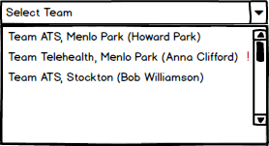

The drop-down allows the Facilitator to:

* + - 1. View a list of all teams (and the UserID of the current Team Lead in parenthesis),
      2. See which chats have a new comment. If there is a new comment (from a Team Lead or another Facilitator), there is a red exclamation point indicated next to the team name and Team Lead UserID.
      3. Select the Team Lead to view/chat. Clicking on a team will unfold the drop-down and show the chat conversation with the selected Team Lead (in the chat area just below the drop-down).
  1. Team Lead View

**Figure 19**  
  
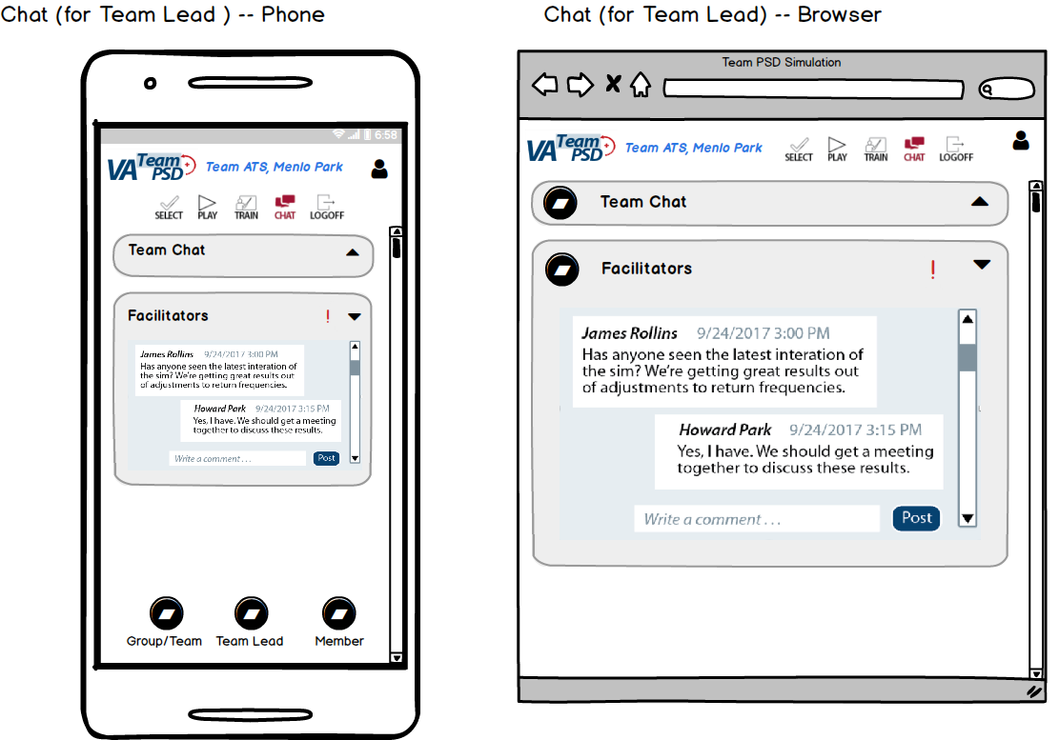

* + 1. The Team Lead Chat is a chat session between all Facilitators and the Team Lead for a specific team.
       1. All Facilitators can access the chat.
       2. Whether the Team Lead tile is available for expansion is dependent on whether the User is assigned to a Team Lead role. If a User’s role changes from Team Lead to a Player, the User’s access to the Team Lead chat is no longer visible.

# Iteration B Design-Related Questions

We can use this section to ask and address questions.

1. Questions for Forio
2. Question to client (VA)

# Recordings of Calls

1. Tue 31-Oct: [recording](https://fccdl.in/92cMYBuRw)
2. Fri 03-Nov: [recording](https://fccdl.in/wuS6LgGb1)
3. Mon 07-Nov: [recording](https://fccdl.in/7AhBm5eEs)